

**InfosysSpringboard Internship 4.0 Project Documentation**

**IMAGE CAPTIONING USING DEEP LEARNING**

*Submitted by*

|  |  |
| --- | --- |
| INTERN NAME | MOAHMMED GOWSHIK G |
| MENTOR | **SUDHEER KUMAR Y** |

# **ABSTRACT:**

* Monitoring Closed-Circuit Television (CCTV) cameras manually is labor-intensive and prone to human error. Automating this process using image captioning techniques can significantly enhance efficiency and accuracy.
* This project proposes a system to automatically analyze CCTV camera footage and generate descriptive captions for the observed scenes. The system leverages deep learning models trained on large-scale image datasets to extract meaningful information from video frames.
* Through this approach, the system identifies objects, activities, and anomalies in real-time, providing contextual understanding of the monitored environment. The generated captions not only describe the contents of each frame but also enable automated alerts for suspicious activities or deviations from normal patterns.
* This automation reduces the burden on human operators, improves response times to incidents, and enhances overall security and surveillance effectiveness.

# **Introduction:**

### Image captioning is a fascinating application of deep learning that bridges the gap between computer vision and natural language processing (NLP). This technology enables machines to generate human-like descriptions for images, transforming pixels into meaningful textual representations.

### The goal of image captioning systems is to automatically generate descriptive sentences that accurately depict the content and context of visual data.

* Traditional computer vision tasks, such as object detection and image classification, focus on extracting specific features from images. However, these methods do not provide a comprehensive understanding of the overall scene or context.
* Deep learning models, particularly convolutional neural networks (CNNs) for image processing and recurrent neural networks (RNNs) or transformers for language modeling, form the backbone of image captioning systems. CNNs extract high-level features from images, which are then fed into RNNs or transformers to generate coherent and contextually relevant captions.
* This introduction sets the stage for exploring the mechanisms, challenges, and advancements in image captioning within the realm of deep learning, highlighting its transformative potential across various fields.

# **PROBLEM STATEMENT:**

Develop an automated system that utilizes image captioning to monitor CCTV camera feeds, generating real-time, descriptive captions for detected activities. This system aims to enhance security and efficiency by providing detailed, context-aware descriptions of events captured on CCTV footage

**BUSINESS USECASE:**

This business use case aims to leverage image captioning technology to transform CCTV camera monitoring, making it more efficient, accurate, and responsive to security needs.

# **Dataset:**

To leverage the Flickr 8k dataset for training and evaluating an image captioning model aimed at automating the monitoring of CCTV cameras. The dataset provides a rich source of labeled images with diverse captions, suitable for developing and refining captioning algorithms.

# **TEXT PREPROCESSING:**

Text preprocessing in image captioning using deep learning involves several essential steps to ensure the input text is properly formatted and prepared for the caption generation task. Here’s an overview of the typical text preprocessing steps:

* **Tokenization**: This is the process of breaking down a text into smaller units, such as words or subwords or characters. Tokenization converts the text into a sequence of tokens that can be processed by the model.
* **Lowercasing**: Converting all text to lowercase helps in standardizing the text and reduces the vocabulary size by treating words like "Word" and "word" as the same token.
* **Removing Punctuation**: Punctuation marks like commas, periods, and exclamation marks may not contribute significantly to the meaning of a sentence in the context of image captioning. Removing them simplifies the text without losing essential information.
* **Handling Rare Words**: Words that occur very infrequently in the dataset can be replaced with a special token (e.g., <unk> for unknown) to manage out-of-vocabulary (OOV) words during training.
* **Handling Rare Words**: Words that occur very infrequently in the dataset can be replaced with a special token (e.g., <unk> for unknown) to manage out-of-vocabulary (OOV) words during training].

**SAMPLE CODE:**

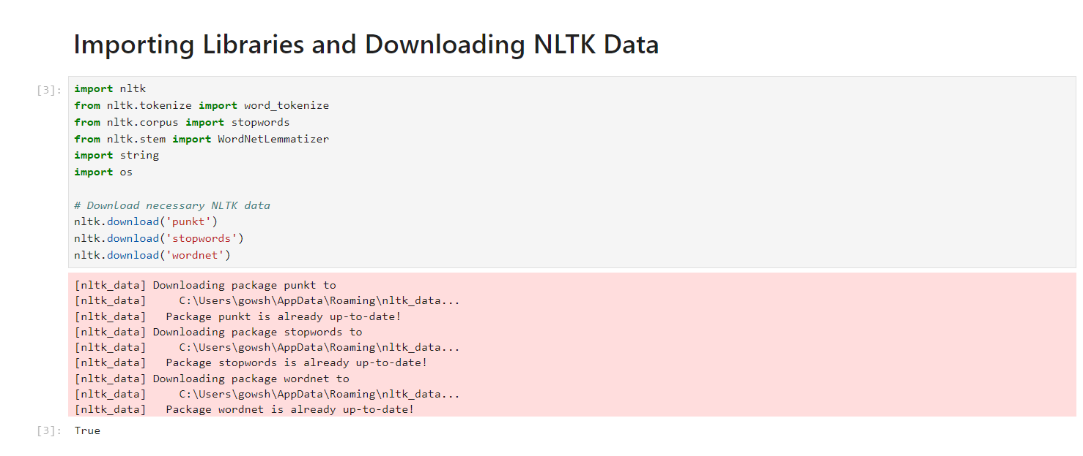

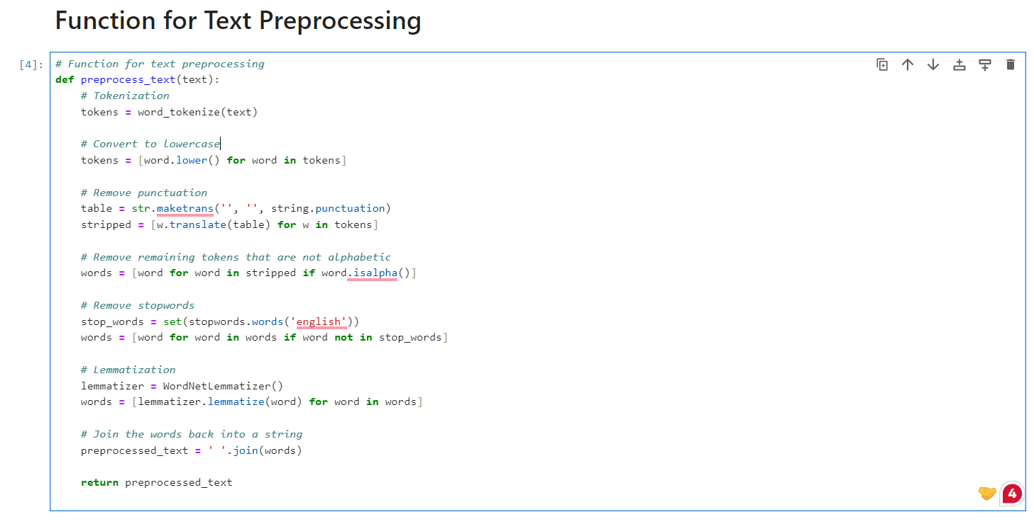

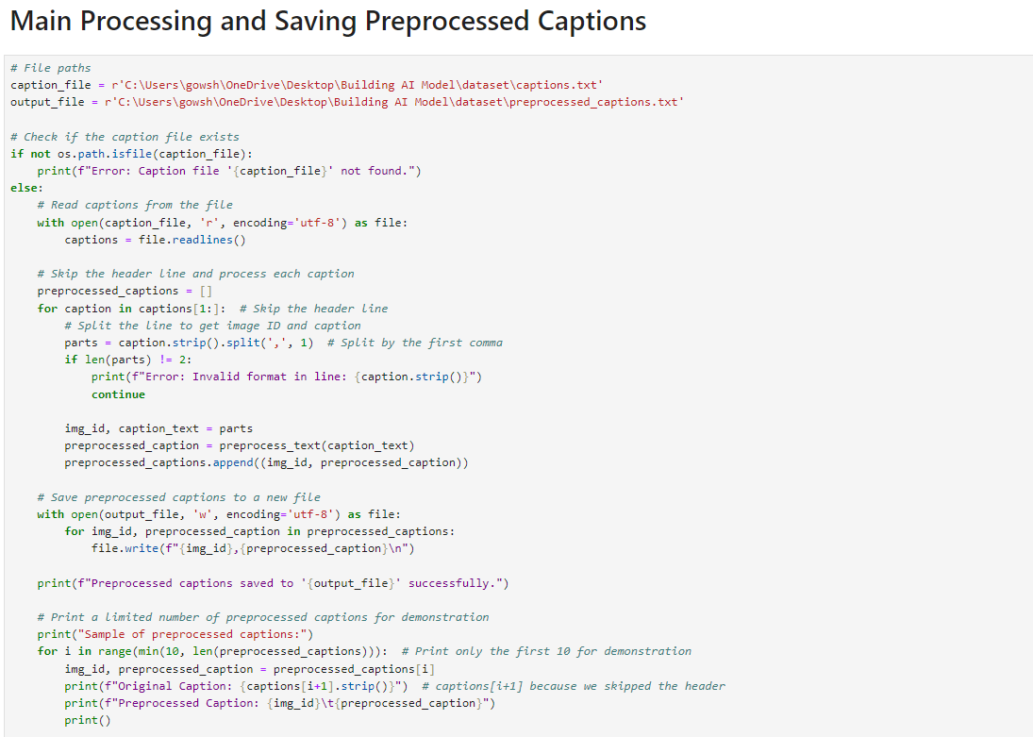

# **IMAGE PREPROCESSING:**

In image captioning using deep learning, preprocessing of images plays a crucial role in preparing the visual data for input into the model. Here’s an overview of IMAGE preprocessing steps typically involved:

* **Image Resizing and Normalization:**Images are often resized to a fixed dimension (e.g., 224x224 pixels) to ensure consistency across the dataset and facilitate efficient processing. Normalization is also performed to standardize pixel values (usually between 0 and 1 or -1 and 1) to improve convergence during training.
* **Data Augmentation:**Augmentation techniques like random cropping, flipping, rotation, and color adjustments are applied to increase the diversity of training examples. This helps in making the model more robust and generalizable to different variations of the same image.
* **Feature Extraction:**Deep learning models for image captioning often use pre-trained Convolutional Neural Networks (CNNs) like VGG, ResNet, or Inception to extract meaningful features from images. These networks are typically trained on large-scale image datasets (e.g., ImageNet) and can capture hierarchical representations of visual features.
* **Text Tokenization and Padding:**In parallel to processing the images, the corresponding captions are tokenized into sequences of words or tokens.s sequences are padded or truncated to a fixed length to ensure uniformity in input size to the captioning model.
* **Data Preparation:**Finally, the preprocessed images and their corresponding tokenized captions are paired and organized into batches for training. Careful attention is paid to maintaining the alignment between images and their captions throughout this process.

# **SAMPLE CODE:**

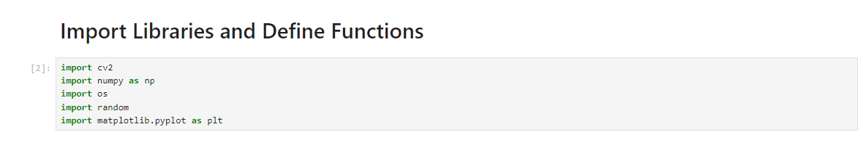

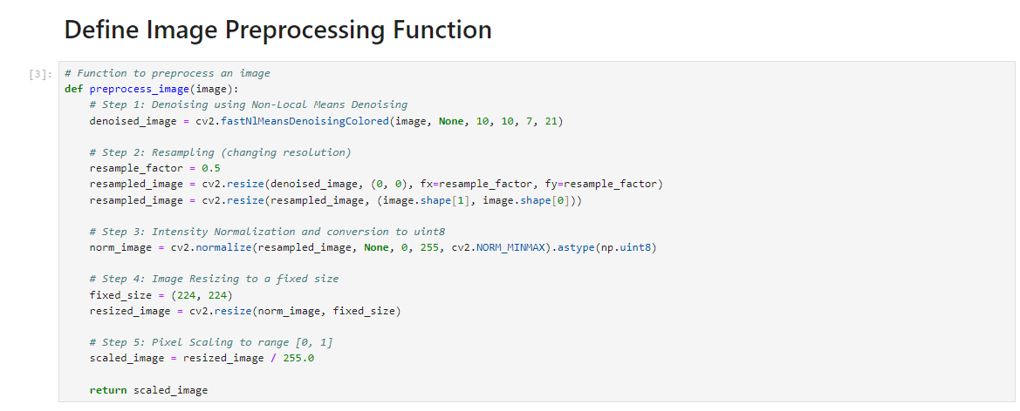

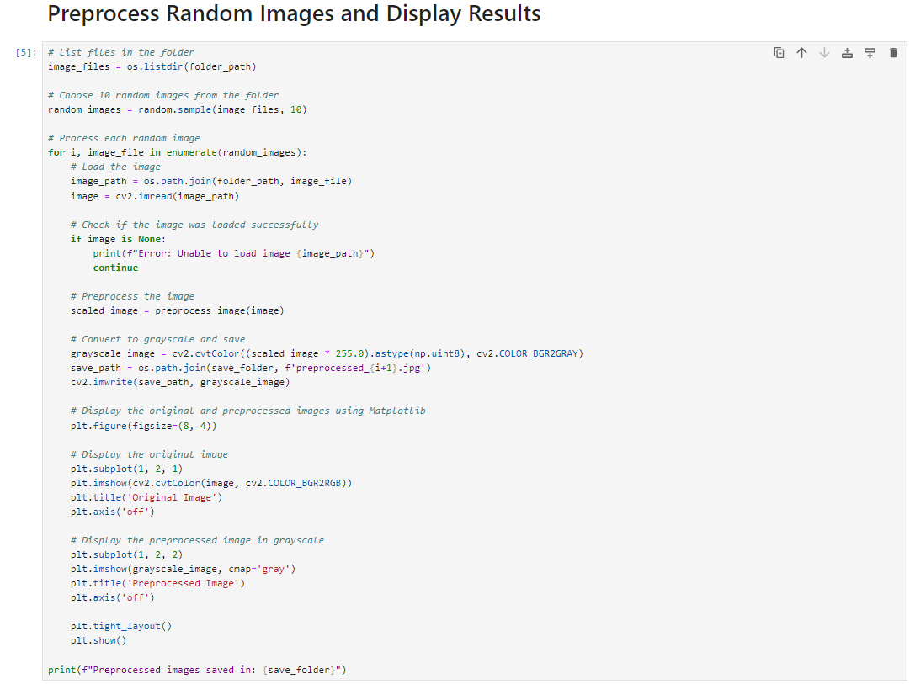

# **MODEL:**

VGG16 for feature extraction and an LSTM-based sequence model for generating captions. Here’s a breakdown of what this means:

* **VGG16 for Feature Extraction**:
  + **VGG16**: This is a convolutional neural network (CNN) architecture that was designed by the Visual Graphics Group at Oxford. It's known for its simplicity and depth, consisting of 16 layers with learnable weights.
  + **Feature Extraction**: In the context of image captioning, VGG16 is used to extract high-level features from images. When an image is passed through the VGG16 network, the network processes it through multiple convolutional layers and pooling layers to produce a feature map. This feature map is a condensed representation of the image, capturing important details such as edges, textures, and object parts.
* **LSTM-based Sequence Model for Generating Captions**:
  + **LSTM (Long Short-Term Memory)**: This is a type of recurrent neural network (RNN) designed to handle sequences of data, such as sentences or time-series data. LSTMs are particularly effective at capturing long-term dependencies in sequences, making them suitable for language modeling tasks.
  + **Sequence Model**: In the context of image captioning, the LSTM-based sequence model takes the feature map generated by the VGG16 network as input and generates a sequence of words that form a coherent caption describing the image. The LSTM processes the image features along with the previously generated words to predict the next word in the sequence, continuing until a complete caption is formed.

# **WORKING OF MODEL:**

* **Image Processing**: An input image is fed into the VGG16 network.
* **Feature Map Generation**: VGG16 processes the image through its layers and outputs a feature map.
* **Caption Generation**: The feature map is then passed to the LSTM network. The LSTM generates the caption one word at a time, using the image features and the previously generated words to predict the next word in the sequence.
* **Output**: The final output is a descriptive sentence that captures the content and context of the image.

This combined approach leverages the strengths of both convolutional networks for spatial feature extraction and recurrent networks for sequential data processing, resulting in an effective image captioning model.

# **SAMPLE CODE:**

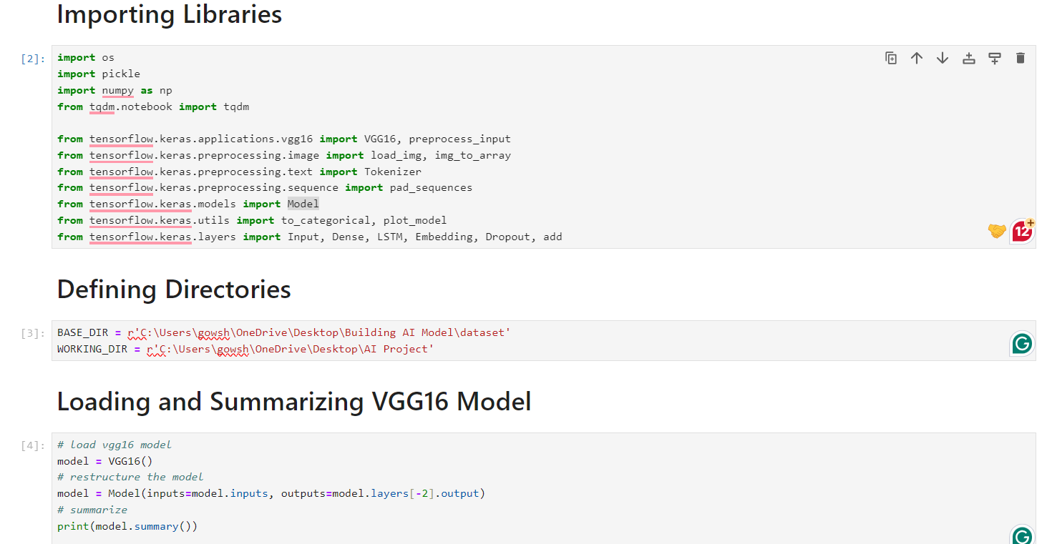

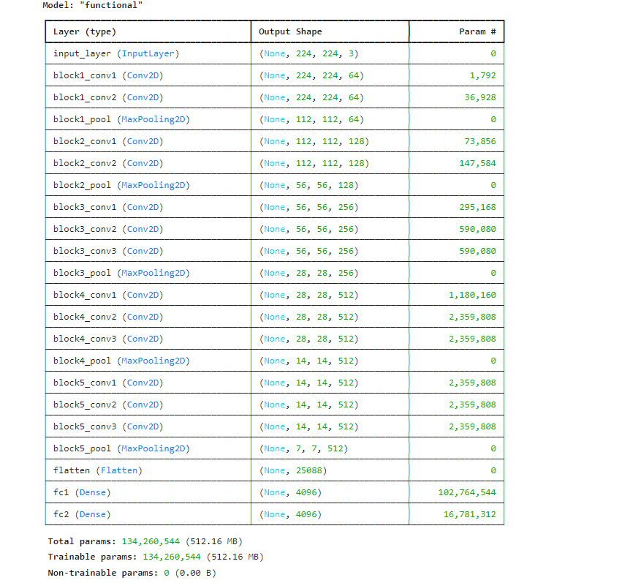

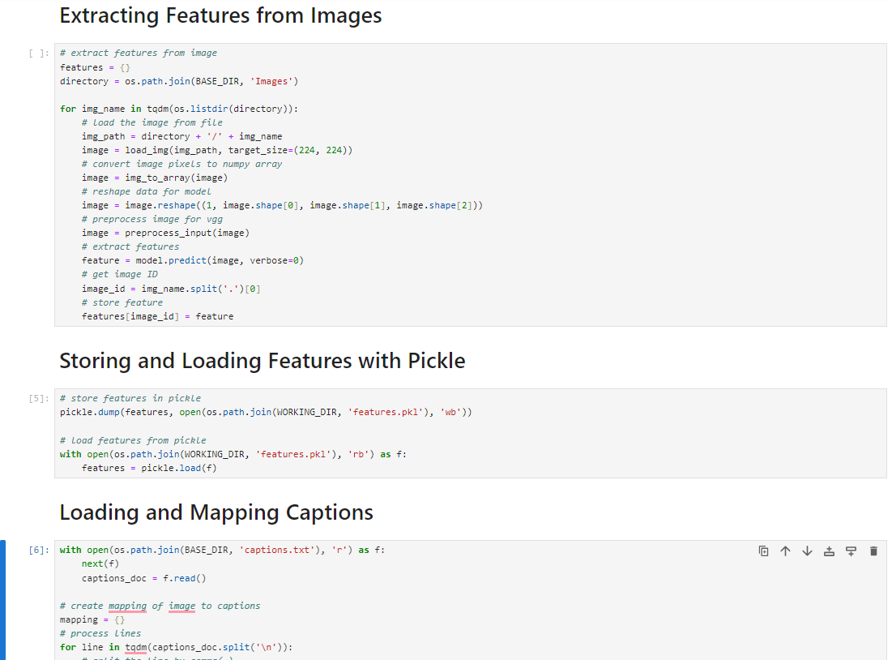

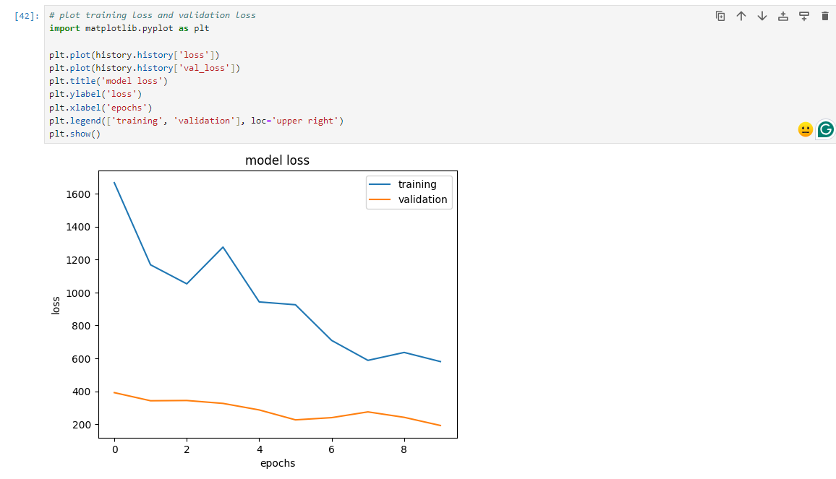

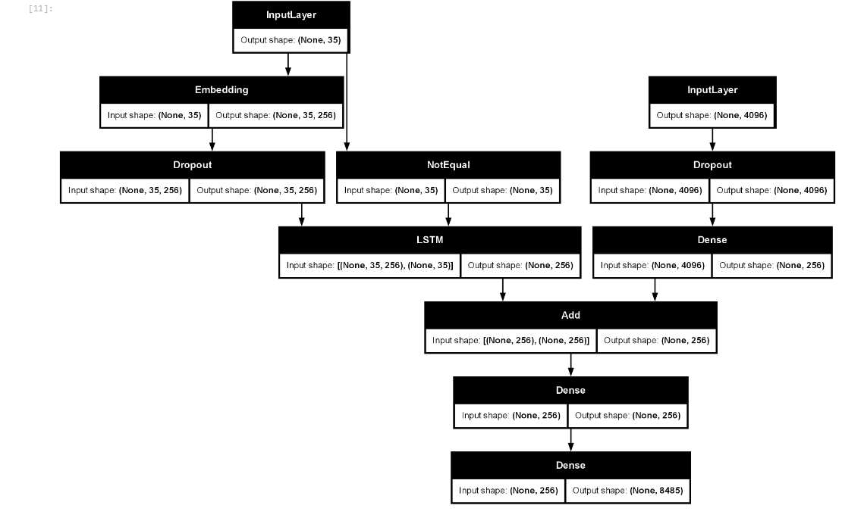

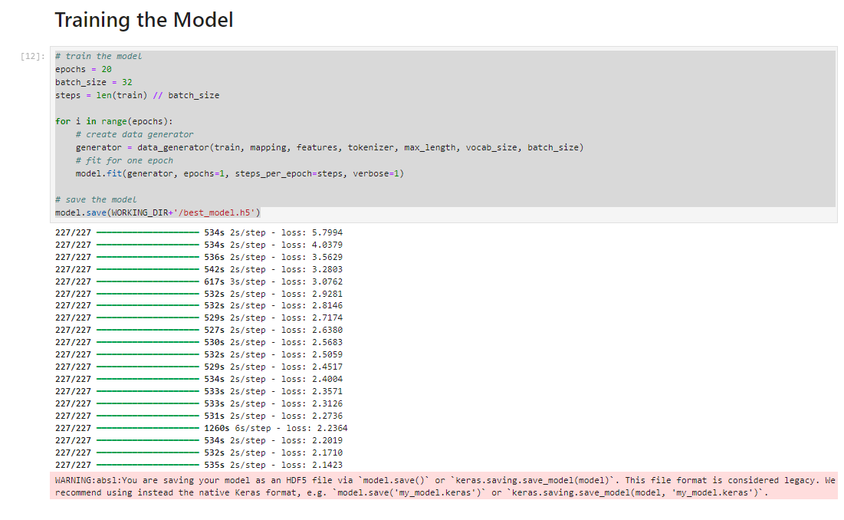

# 

# **OUTPUT:**

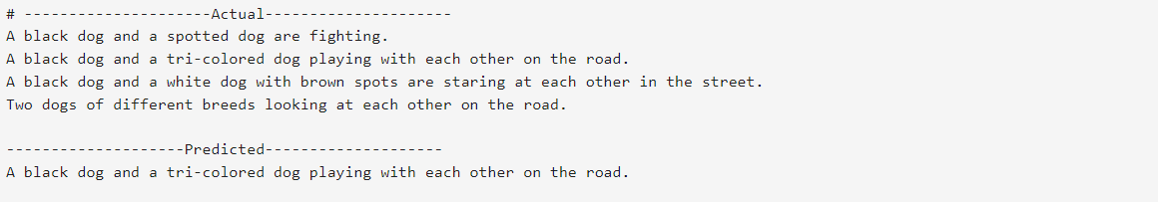

**CONCLUSION:**

* The image captioning system combines a pre-trained VGG16 model for feature extraction and an LSTM-based model for generating captions. The model is trained on a dataset of images and their corresponding captions, and evaluated using BLEU scores. The system demonstrates the ability to generate descriptive captions for images, and the BLEU scores provide a quantitative measure of the quality of these captions.
* In practical applications, such an image captioning system can be useful in various domains such as automatic image annotation, improving accessibility for visually impaired individuals, and enhancing image search engines. Future improvements can include using more advanced architectures like attention mechanisms to further enhance the quality of generated captions.